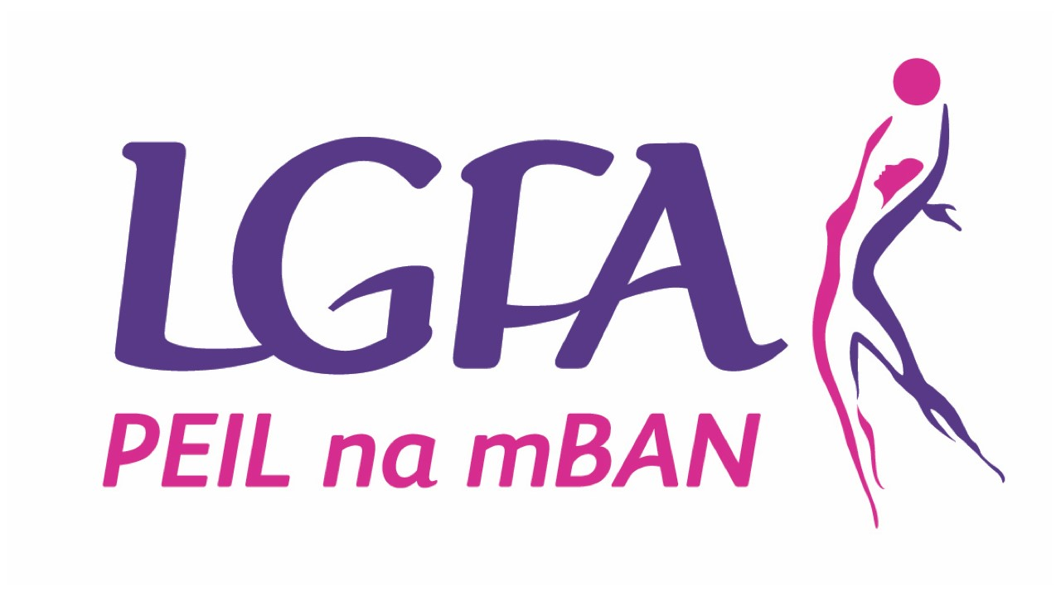

Galway Ladies Gaelic Football Association
Inter County Management Application Form

Position applied for: Galway Intercounty Minor Manager

- Personal Details (Please use capital letters):
Name:
Address:
Email:
Phone:
Mobile:
Club:

- Code of Ethics & Good Practice for Young Players
Garda Vetting:
Please attach a copy of your Garda Vetting Certificate to application, if you have not yet applied to be Garda vetted please visit https://ladiesgaelic.ie/lgfa-hub/clubs/child-welfare-protection/vetting/ ASAP

- Coaching qualifications (Please tick relevant box):
LGFA Intro to Gaelic Games Coaching Course |  |  |  | LGFA Level 1 Coaching Course |  |  |  | LGFA Level 2 Coaching Course
Yes |  | No |  | Yes |  | No |  | Yes |  | No
Date: |  |  |  | Date: |  |  |  | Date:
Please list the name of other coaching courses you have completed which is relevant to your application:

- Management Experience:
List previous managerial roles / experience (applicable to club / county):
- Playing Experience
List previous playing experience (applicable to club / county):

- Proposed Management Team:
(Applicants must specify their full management team prior to interview stage)
Position | Name | Club | Garda Vetted
Position | Name | Club | Yes | No
Team Selector
Team Selector
Female Selector
Team Administrator
- References:
Please supply the name, address and contact details of two people whom the Galway LGFA can contact that from their personal knowledge are willing to endorse your application.
Referee (1): | Referee (2):
Name: | Name:
Address: | Address:
Address: | Address:
Email: | Email:
Number: | Number:
Position: | Position:
- General Information:
a) Do you agree to abide by the guidelines of Code of Behaviour for Gaelic Games? | Yes | No
b) Do you agree to abide by the rules of the Ladies Gaelic Football Association and the Galway Ladies Gaelic Football Association? | Yes | No
c) Do you agree to abide by the Galway LGFA Code of Best Practice for Inter County Management | Yes | No
- Any other relevant information:
List any additional qualifications, skills or experiences that may be relevant to position applied for & attach certificates of qualifications:

- Budget
Please provide a draft annual budget, upon agreement with management team, using the attached template as to the expected running costs of your team (costs should include expectations for professional services
- Signature: ________________________________ Date: / / /

